Detecting Deep Fake Faces

“Deep Fakes” is a popular image synthesis technique based on artificial intelligence. The goal of “Deep Fakes” is to capture common characteristics from a collection of existed images and to figure out a way of enduing other images with those characteristics, e.g. shapes and styles. Generative adversarial networks (GANs) is the one of most frequently used ways to implement a “Deep Fake”.

Datasets

CelebA dataset - <http://mmlab.ie.cuhk.edu.hk/projects/CelebA.html>

Liu, Ziwei and Luo, Ping and Wang, Xiaogang and Tang, Xiaoou, (December 2015) - Deep Learning Face Attributes in the Wild, Proceedings of International Conference on Computer Vision (ICCV)

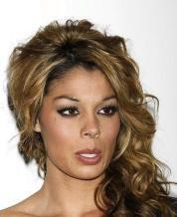

1 Million Fake Faces dataset. <https://archive.org/details/1mFakeFaces>

Images are generated using NVIDIA's StyleGAN and released them under the same CC BY-NC 4.0 license

Published by NIVIDIA LABS

Goal for the project

* Train a Neural Network to Detect facial features, Gender, Age group and other attributes from the CelebA dataset images
* Test on fake faces determine whether the image belongs to a real person or not